Page replacement

Algorithm

Name:Youssef karam

Id:2019/03816

At first I would like to present the easiest way to calculate page fault of the following algorithm(FIFO,LRU,optimal)

At first when you run the program its going to ask you to put the number of pages you want .i suggest to put{7, 0, 1, 2, 0, 3, 0, 4, 2, 3, 0, 3, 2}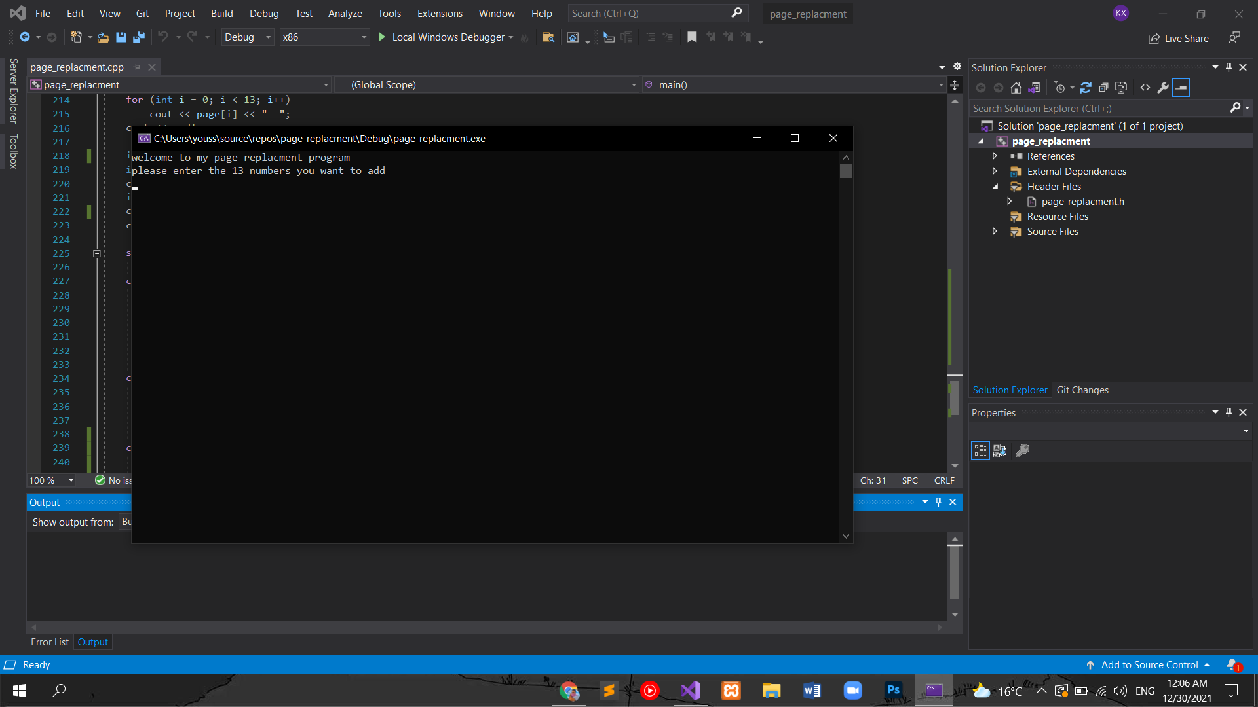

After adding the pages its going to ask you which algorithm you want to use (FIFO,LRU,optimal),choose whatever you want.

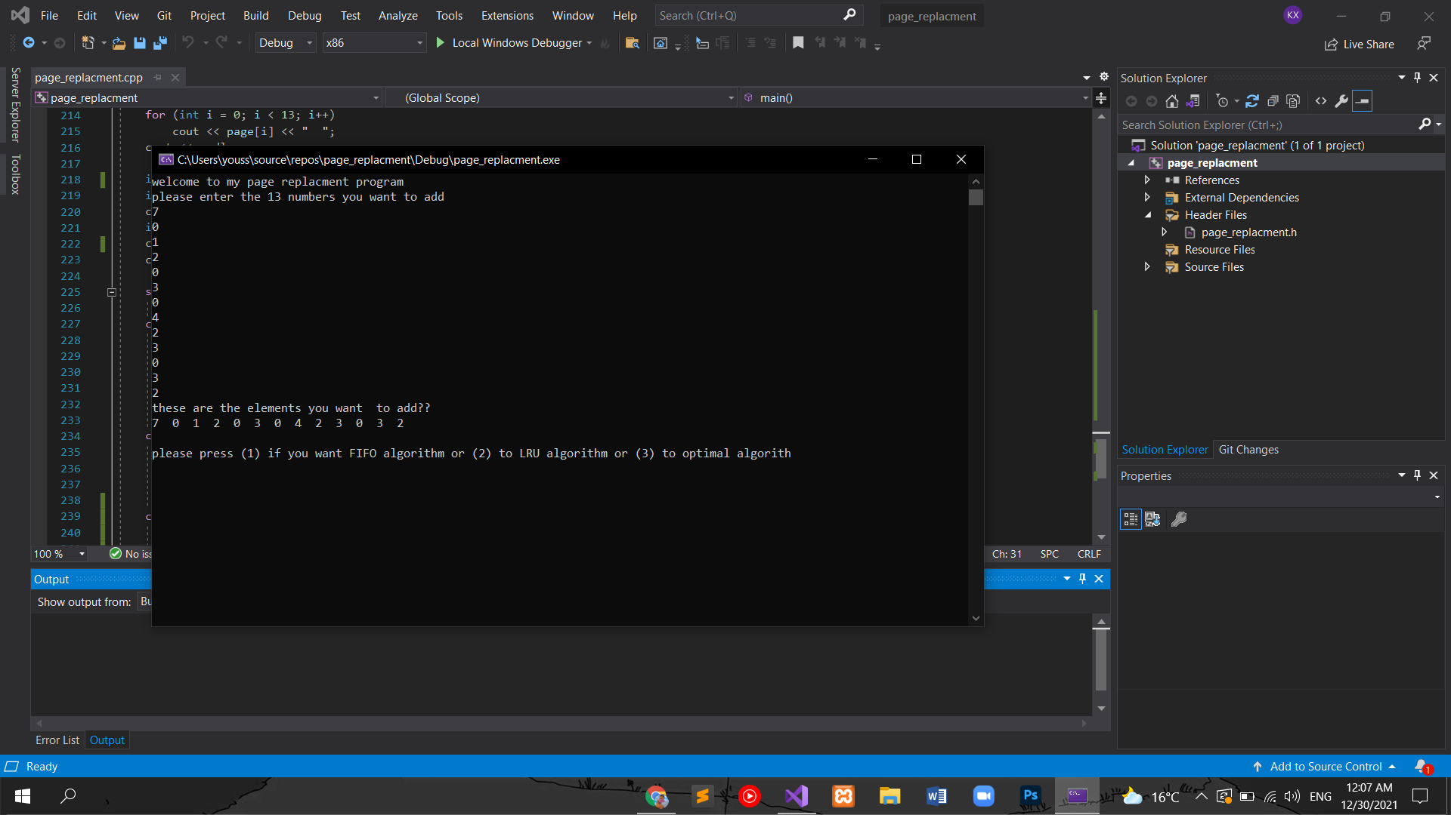

After choosing its going to calculate the page fault for you.

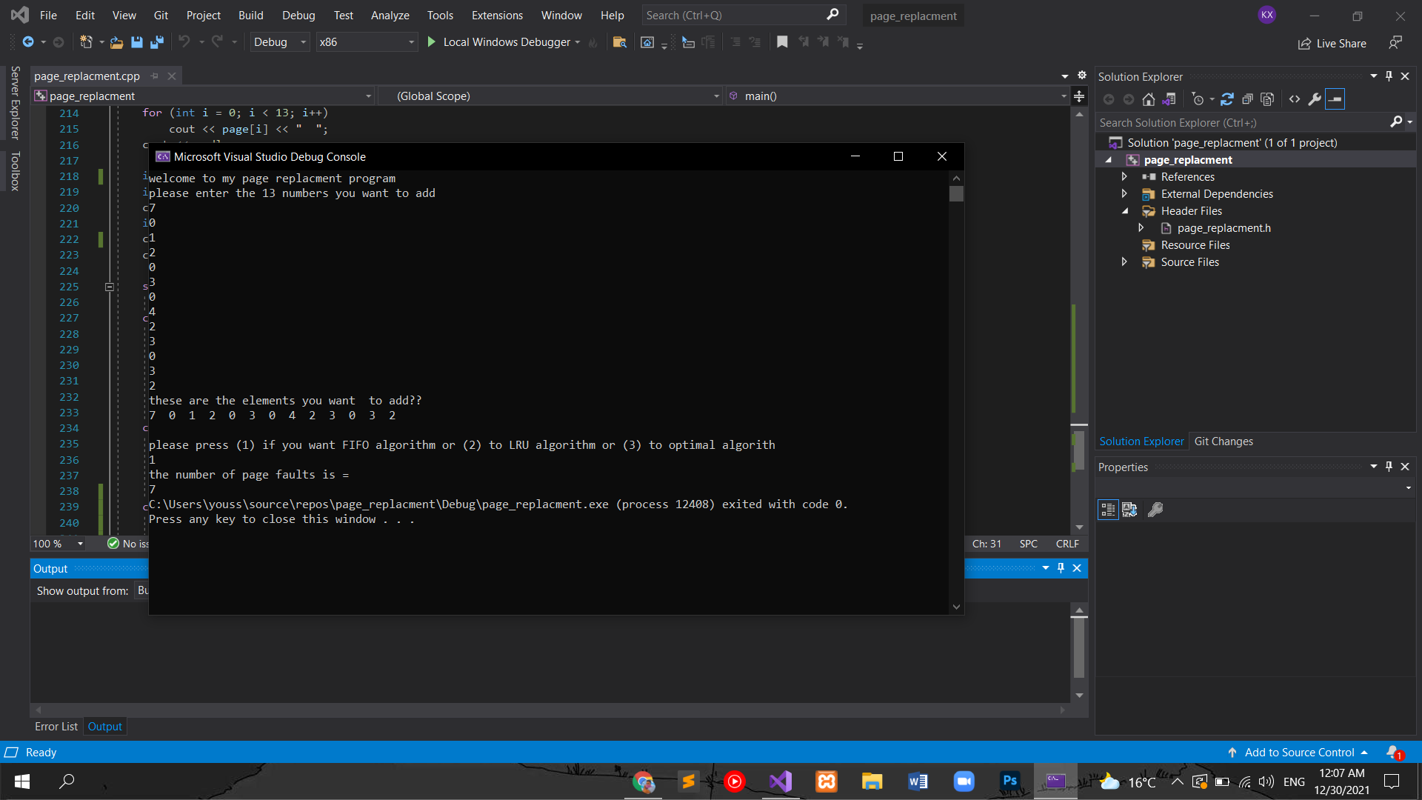

And here is a screen shot for the other algorithms page fault.(LRU)

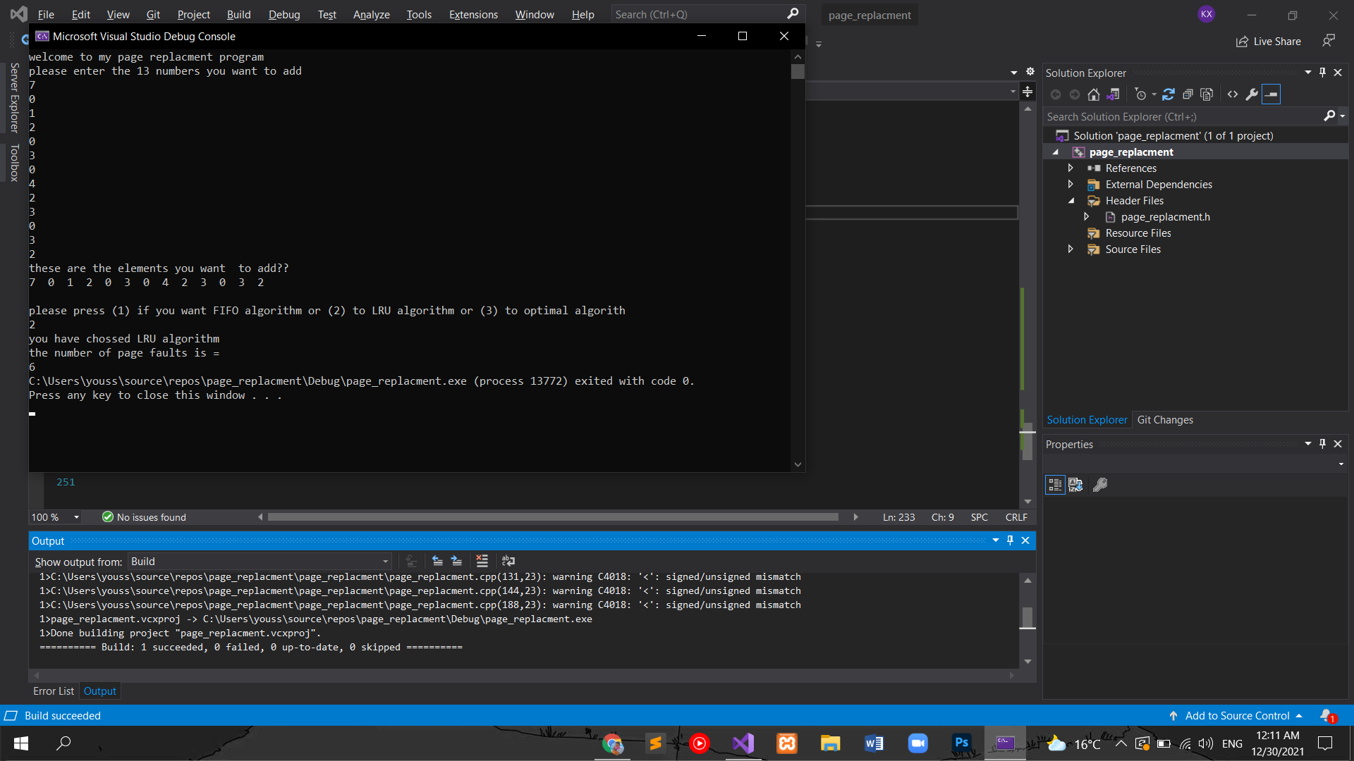

(optimal)

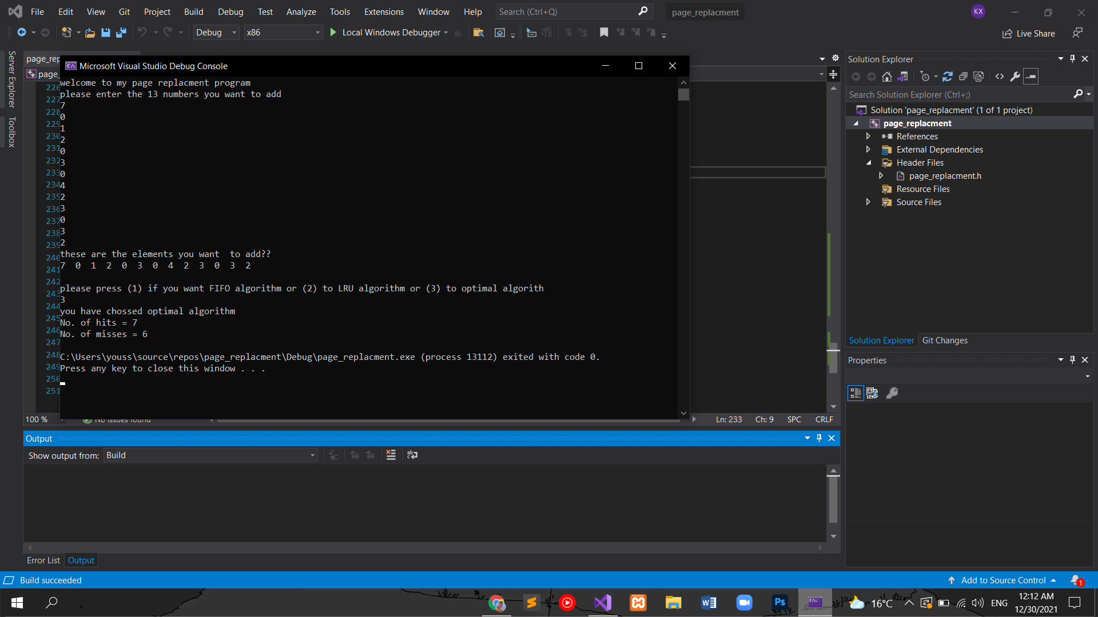

At the end it’s a very simple code to achieve the best results .